Narendra Jana
Email: realn@mykolab.com
Phone: +17812235780
Section 4
External physical injury due to the hospital murder attempt of me on November 23rd 2021 pictures. They physically restrained me in their murder attempt of me so I have external bruises along with punctures from the toxic drug they injected to try and cause a heart attack (as seen in the blood tests).

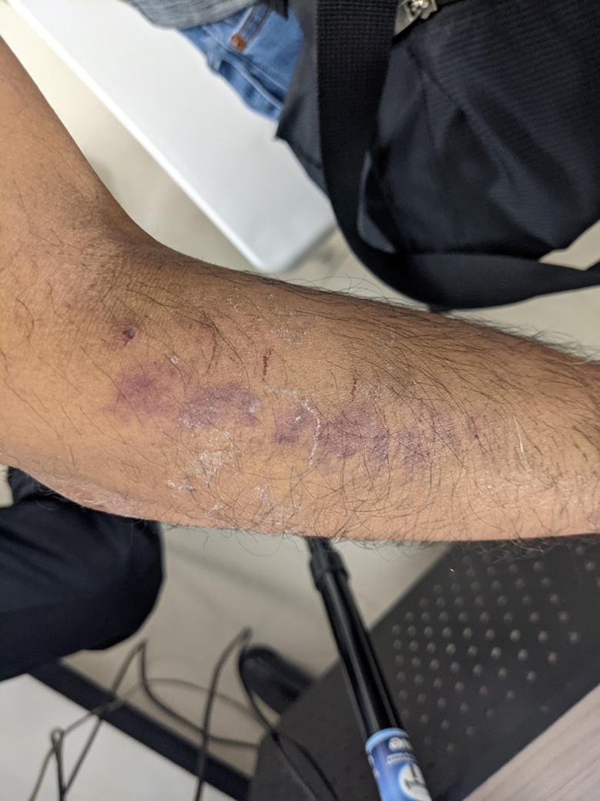 | 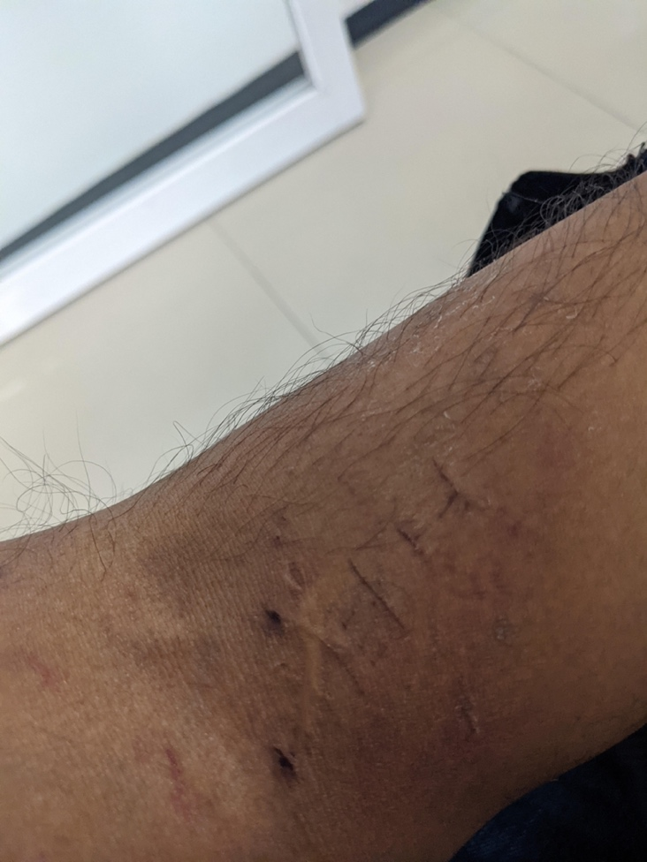  The vertical lines cuts are by the hospital nurses and doctors during their murder attempt of me.
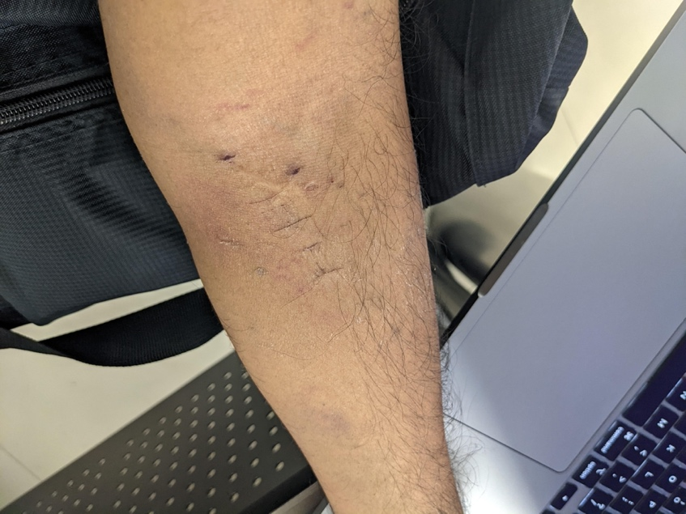 | 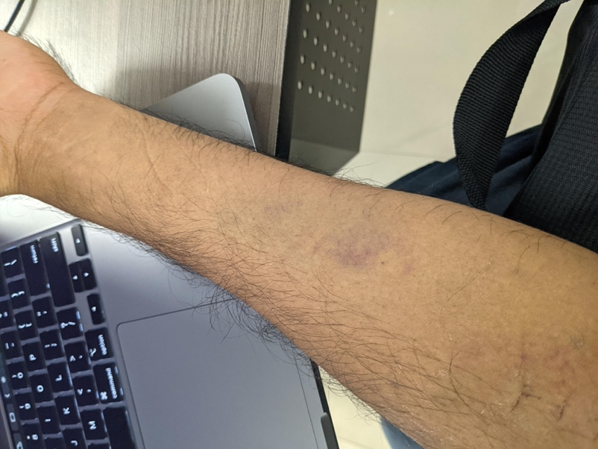
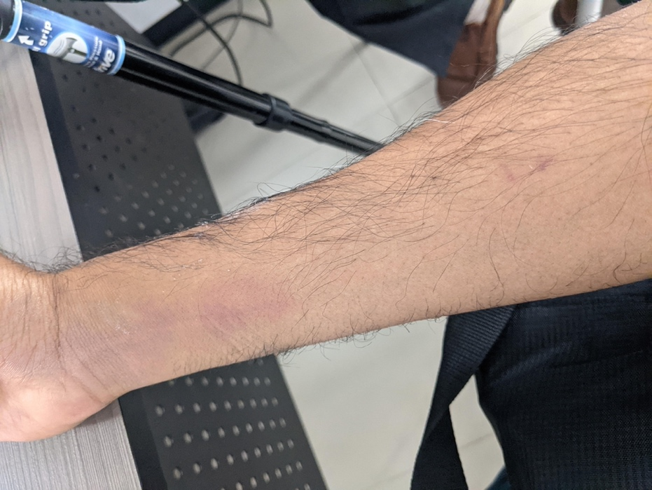 | 