Narendra Jana
Email: realn@mykolab.com
Cell: +1(781)2335780

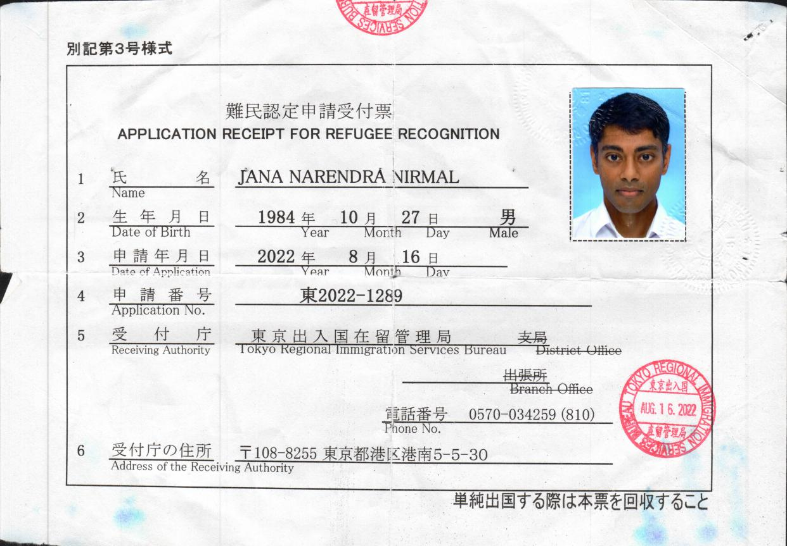
Narendra Jana’s Japanese Refugee where the US made Japan replicate the harm caused to me in the US so I had to leave.

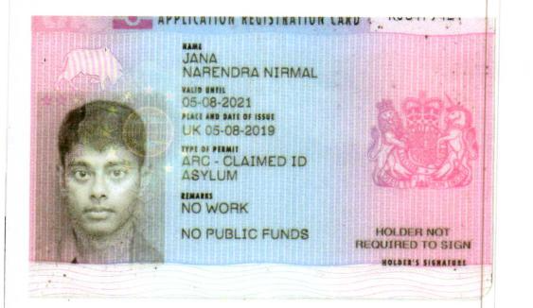
Narendra Jana’s UK Refugee where the US politically influenced the UK to replicate and further harm me.

