Narendra Jana
Email: realn@mykolab.com
Cellphone: +17812235780

The US Forces Sexual Incongruity (Rape) by Causing Intentional Brain Damage
The United States did this:
They caused enough damage to the temporal lobe regions of my brain so that it would cause persistent seizures and hypersexuality. (this falls under the category of intellectual disfigurement through medical mistreatment or changing the behavioral patterns of a person by causing neurological damage intentionally).
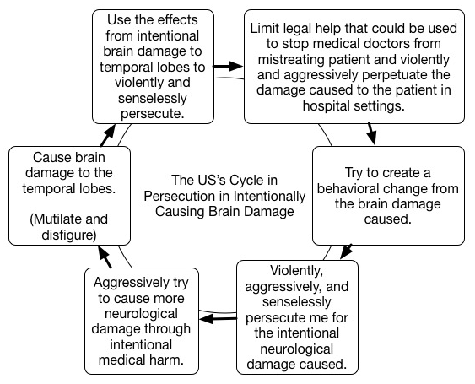
Its the same as drug facilitated sexual assault but through brain damage. Eg. giving a person a date rape drug and then assaulting them when under the influence of the drug.
In my case doctors in the US intentionally falsified diagnostics and withheld medications to cause seizures and brain damage. US used the impressionable mental states created by the neurological condition in medical neglect though withholding medications to sexually assault (rape) me. It was done throughout my case.
I have video recordings of the US forcing sexual incongruity (rape) in person as well in severe and intentional states of medical negligence (doctor caused intentional brain damage) which I could show with a legal intermediary.
The country also used internet search engines to play with the effects of the neurological damage caused; they are fully aware of what they are doing:
I have video recordings of the US using search engines (google and bing) to try and instigate me in severe and intentional states of medical negligence which I could show with a legal intermediary.
The US also socially isolated me while keeping me medically ill to sexually assault (rape) me:
The US had by 2014 keep me intentionally isolated for more almost a decade. Limiting all interpersonal contact with adult females specifically and thus limiting the formation of all adult relationships intentionally (with clear evidence). I am a heterosexual male. On top of which they tried to change my social behavioral patterns by intentionally causing brain damage and violent social malice.
The US tried to change my sexuality by causing brain damage intentionally. They have a delusion that a heterosexual male could be changed from being heterosexual by brain damage.
The US socially isolate me, sexually assaulted (raped) me, and brain damaged me for no reason.

