Narendra Jana
September 11th 2023

This note is to my parents:

I was physically harmed in recent events (over the last few months) and you guy should know about it. Its to tell you why I seek safety in perticular places and to safe guard you. Here is the situation and the historical basis of it:
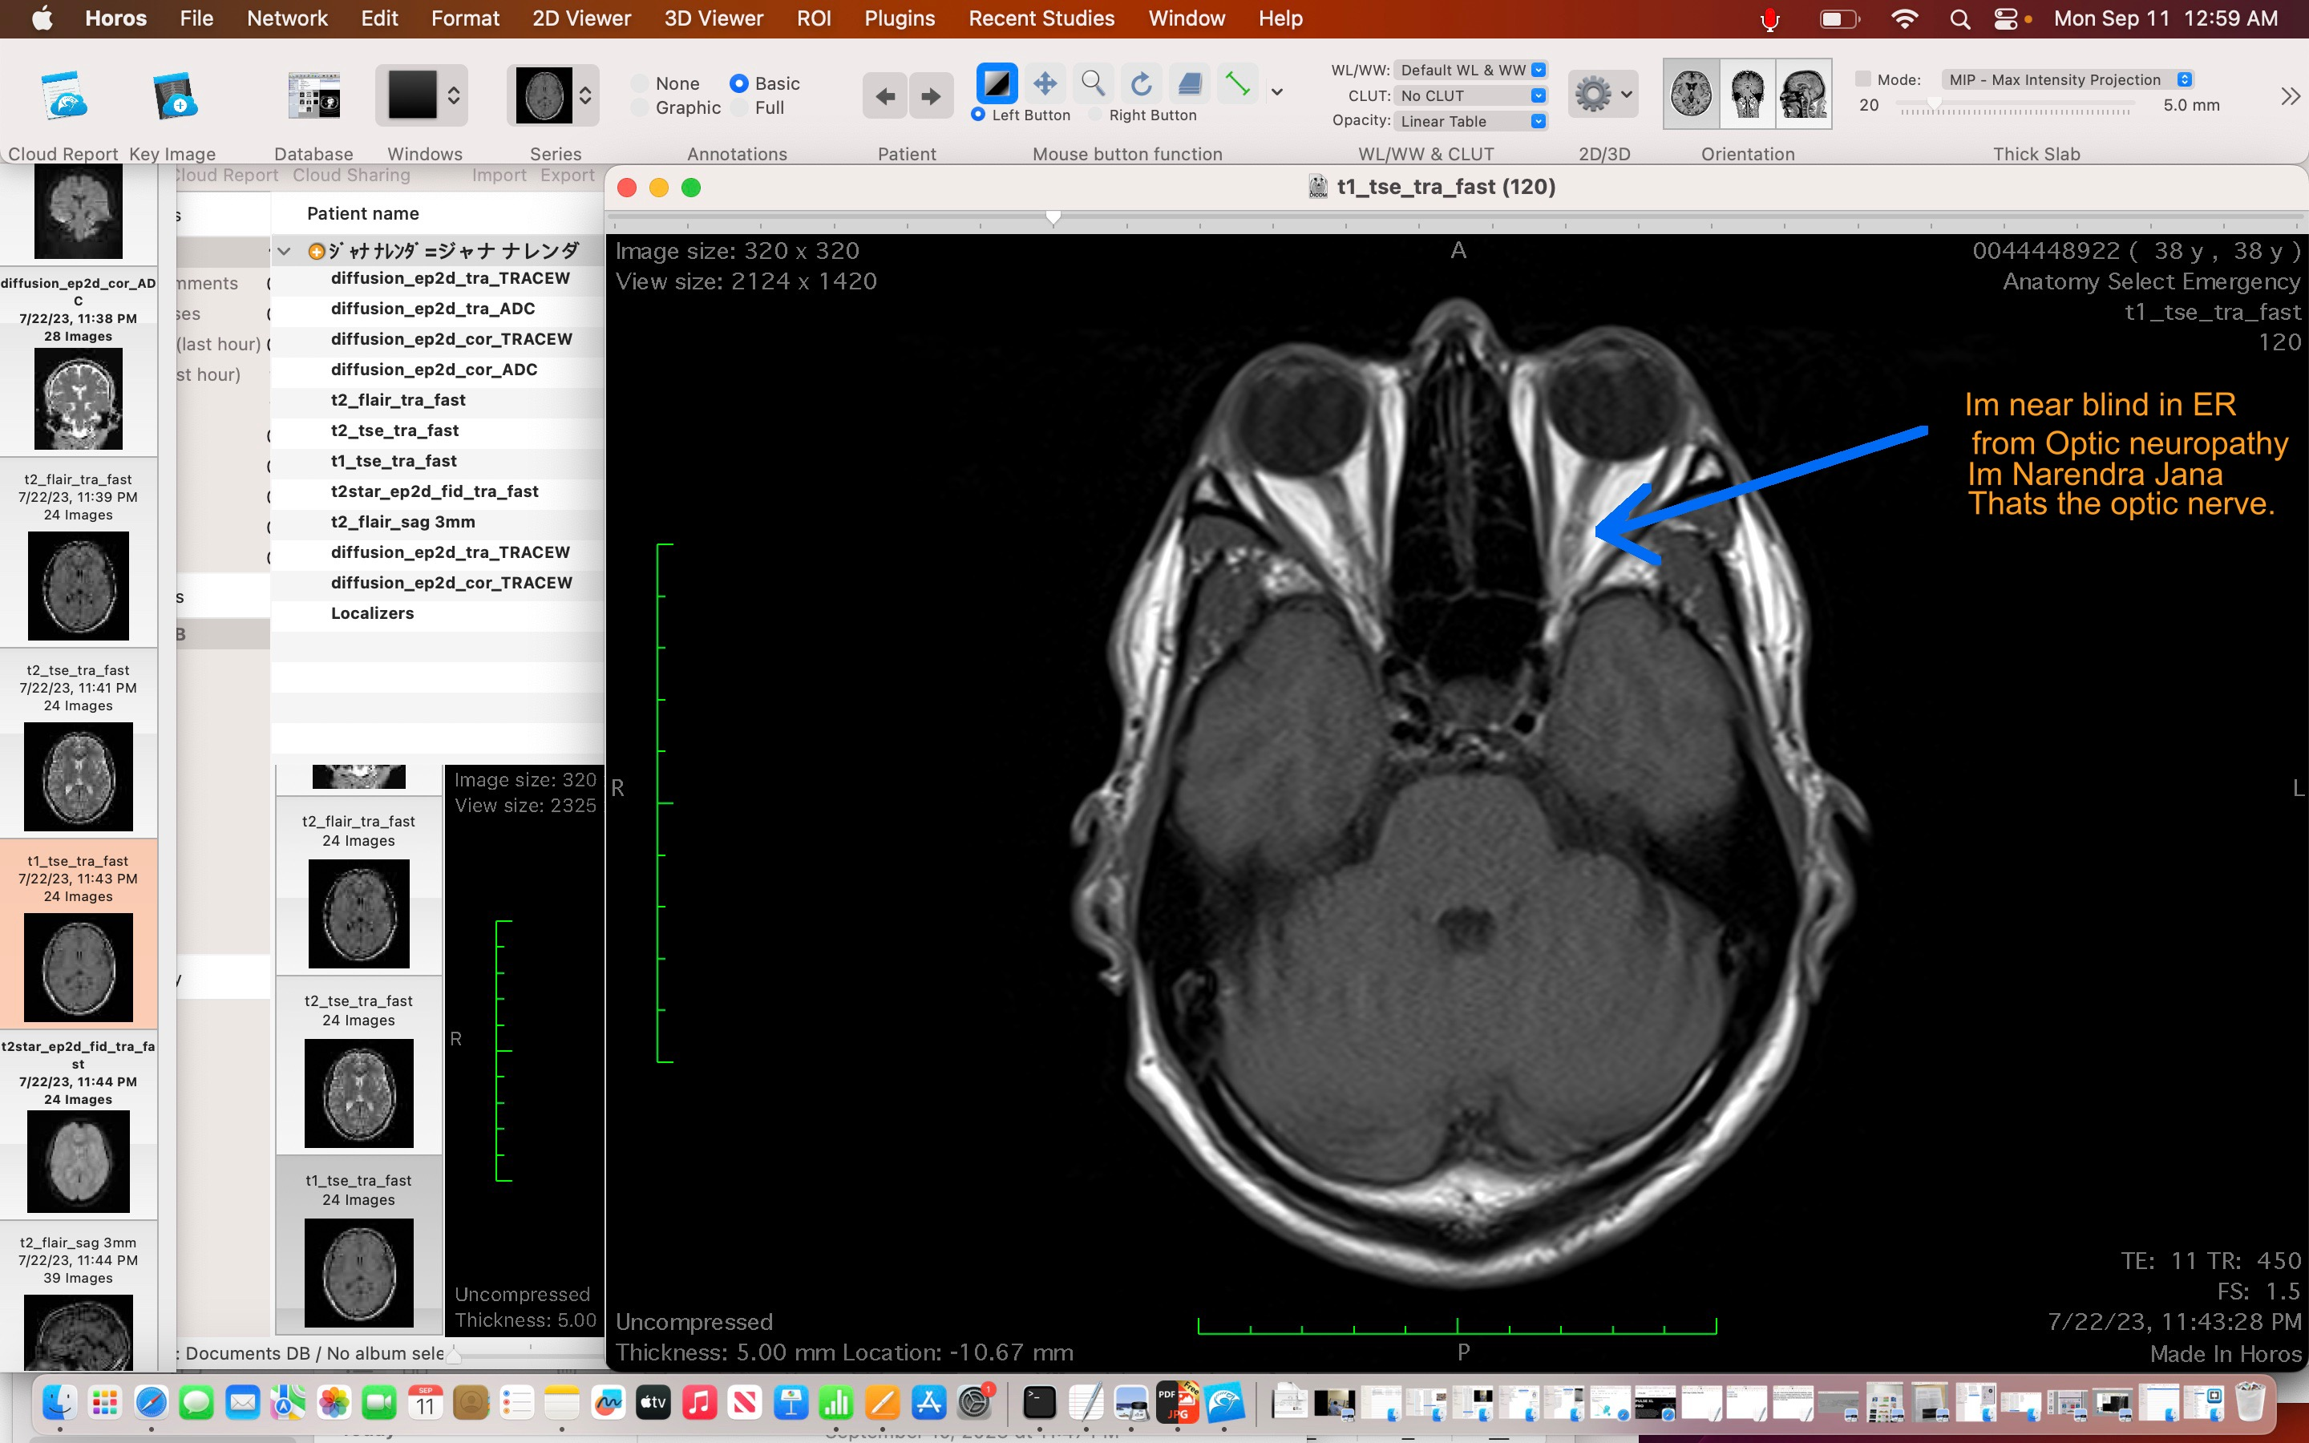
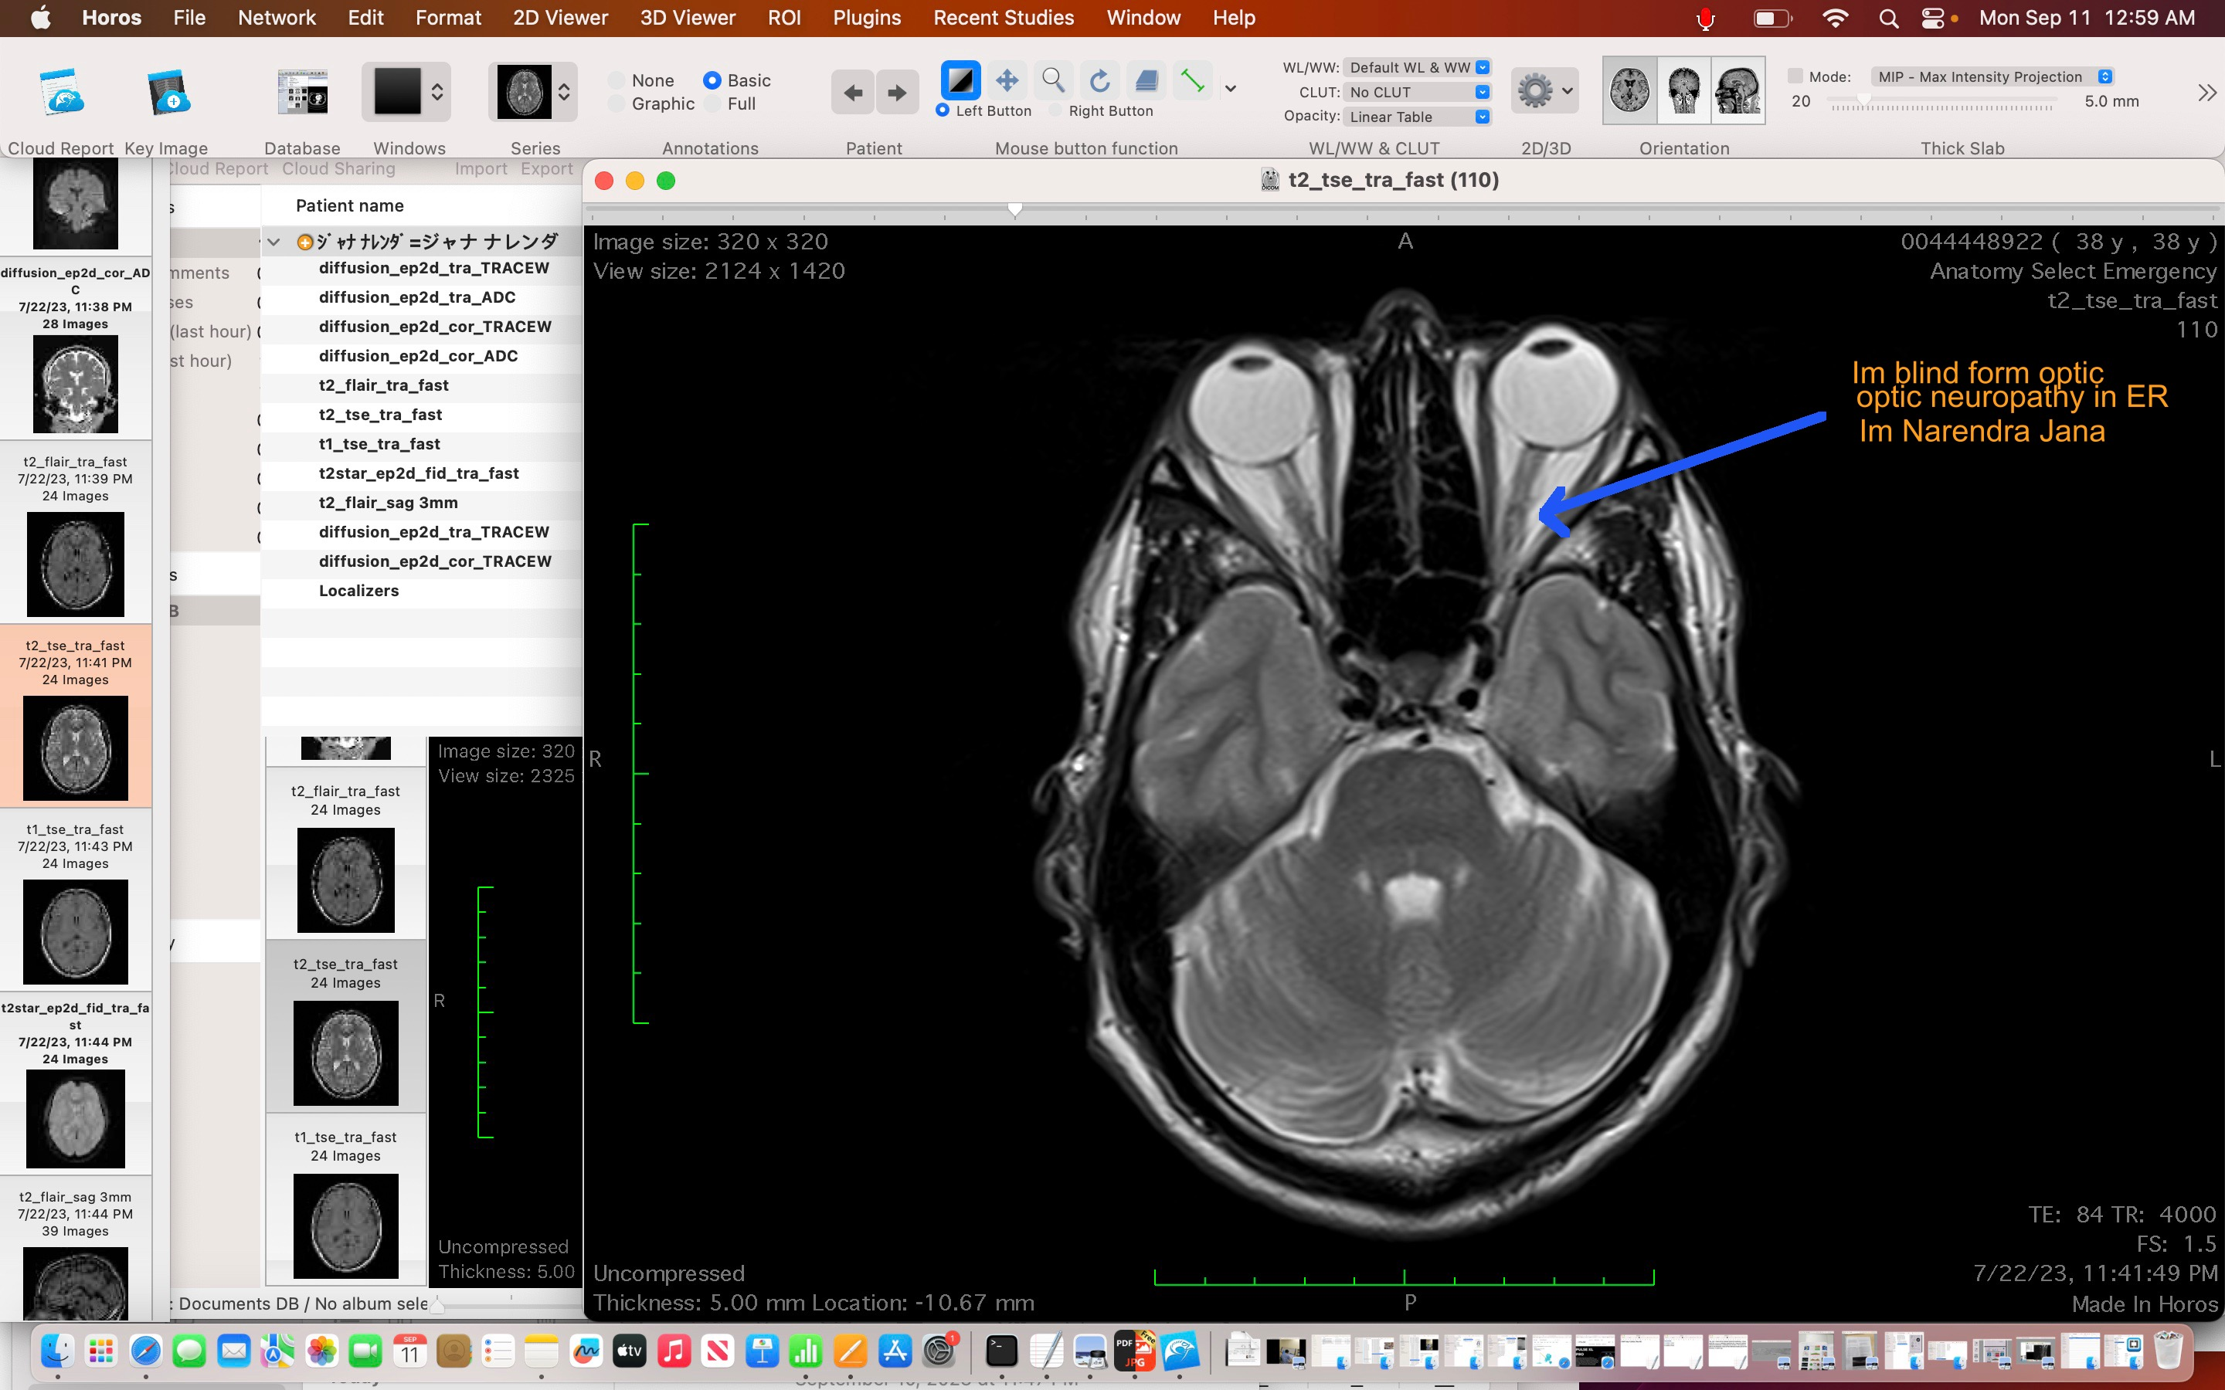
In recent events the first clinical/physical assault of me was on July 22nd 2023, I lost vision in both eyes due to a multiple sclerosis relapse and instead of the doctors giving me the typical medications for the condition in severe emergency they doctor physically/clinically assaulted (harmed) me in Tokyo, Japan:
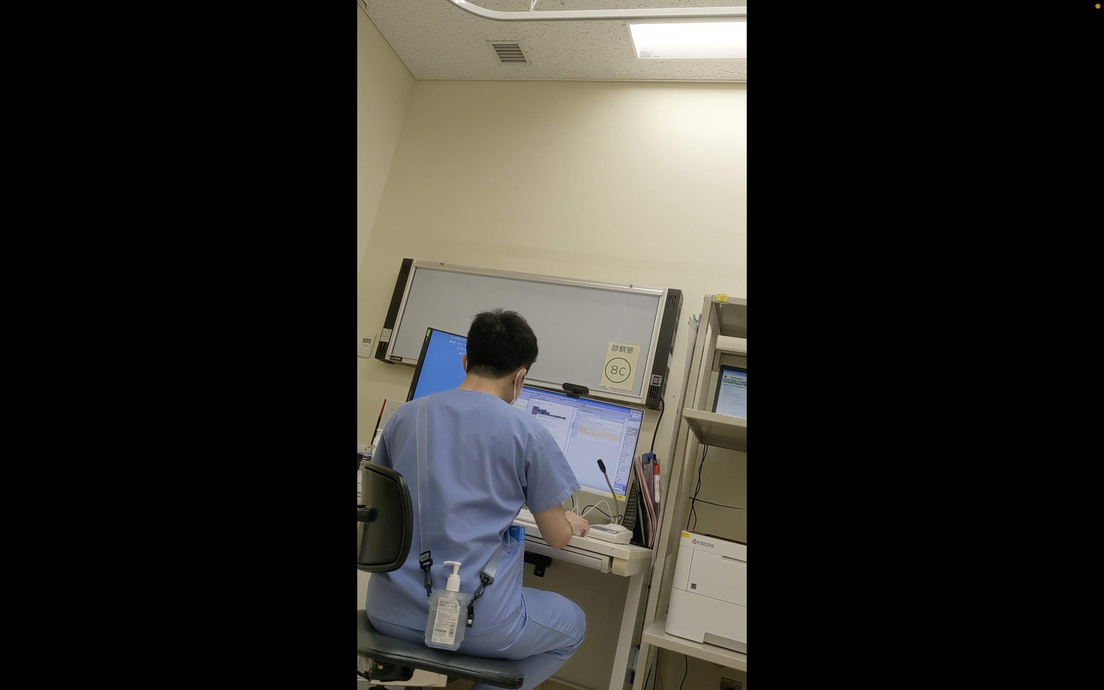
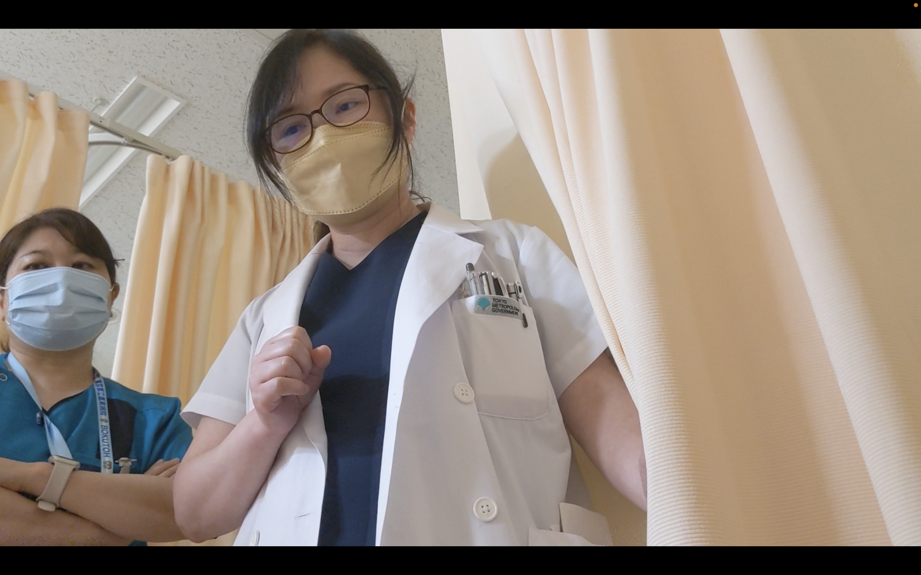
(these pictures are from videos with audio but I cant place a video in a document)
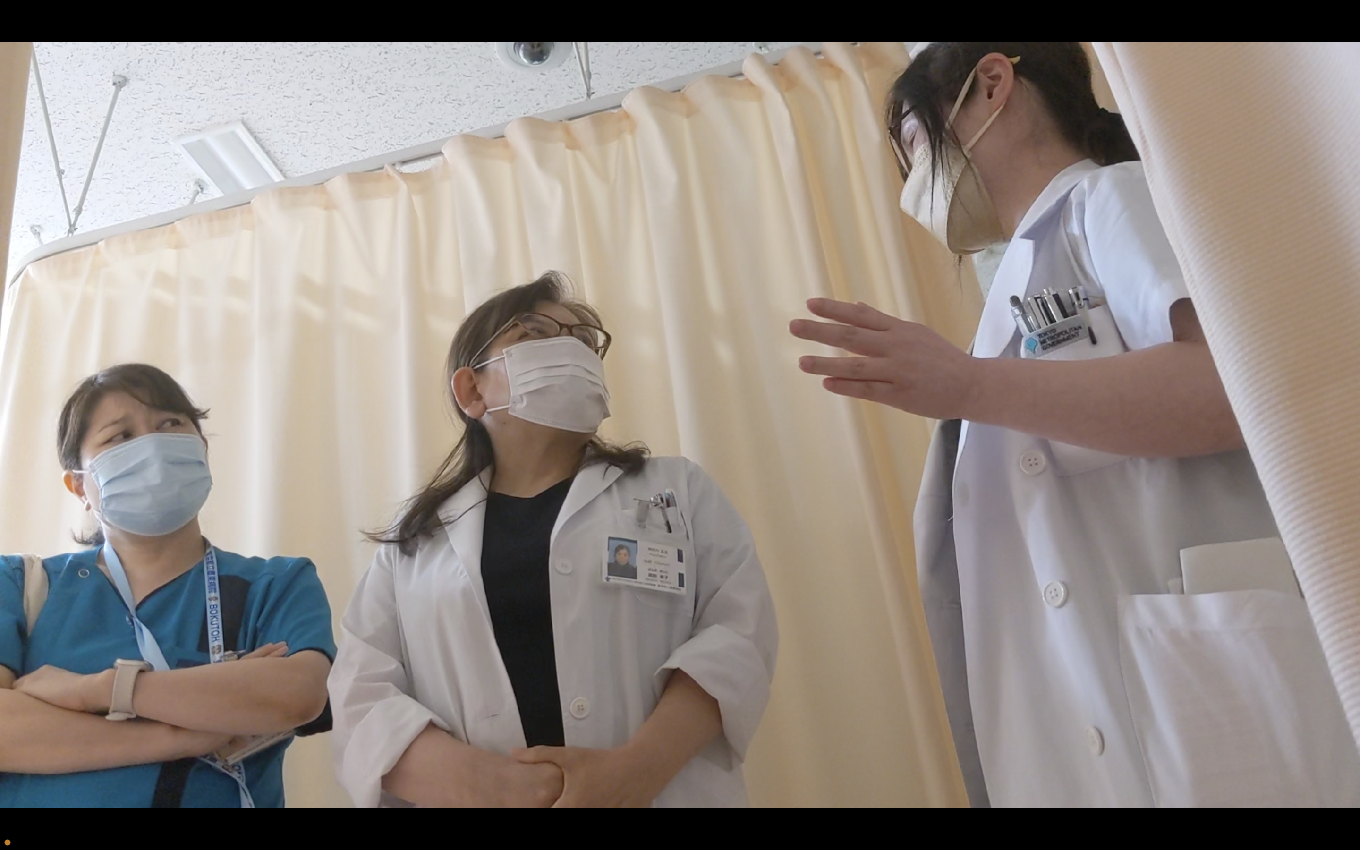
I didn’t have medial help so I flew to Lyon, France from Tokyo, Japan for help. On September 3rd 2023, the doctors in Lyon, France repeated the behavior of clinical assault but in this instance they physically assaulted me. Its the same medical emergency requiring severe emergency treatment. I was sick on the flight to France.

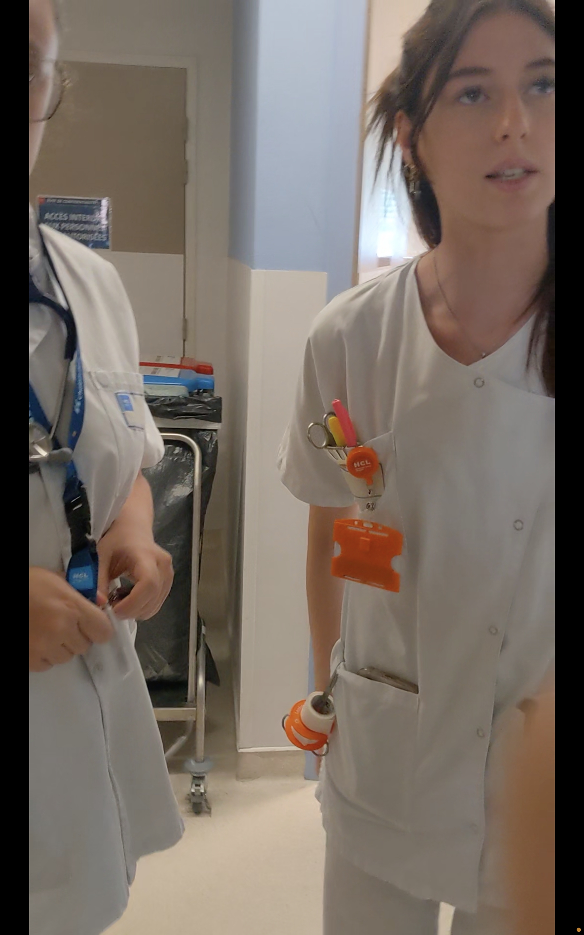
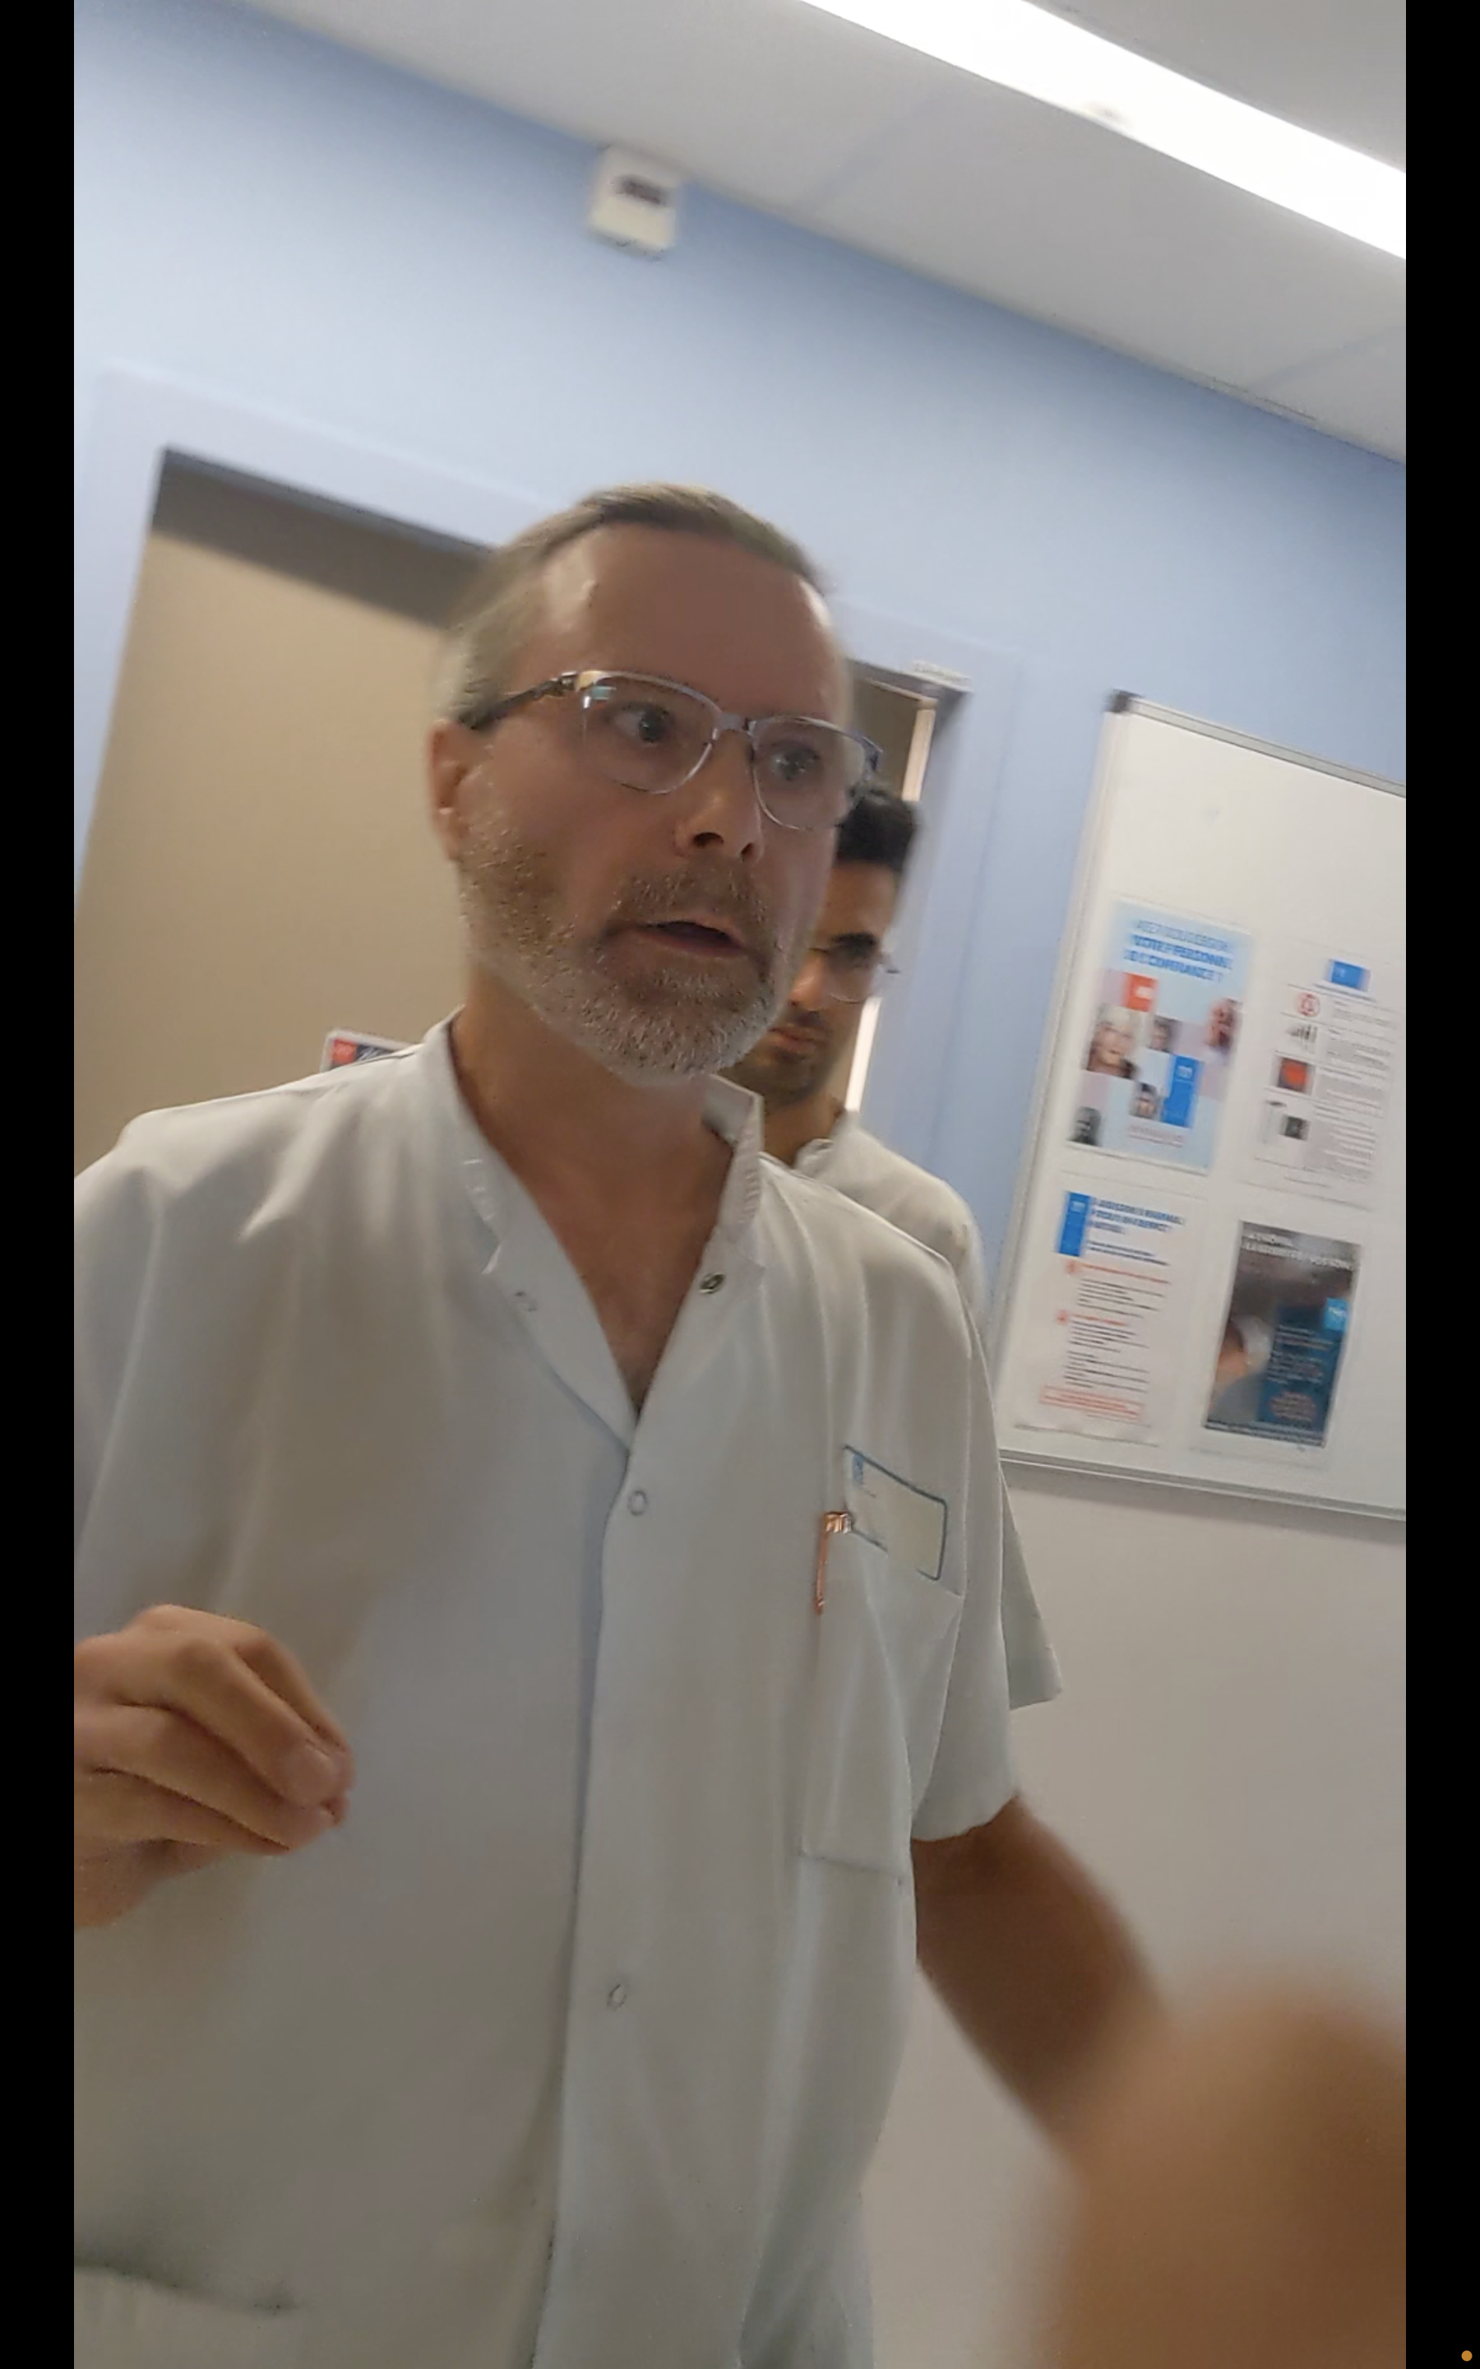



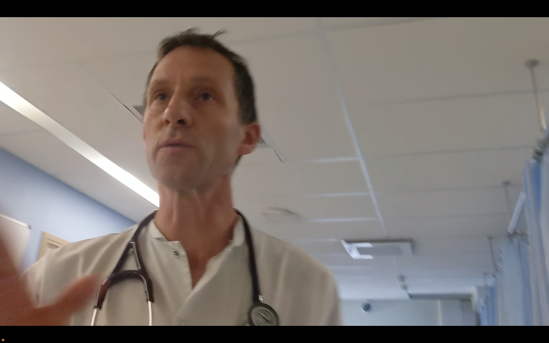

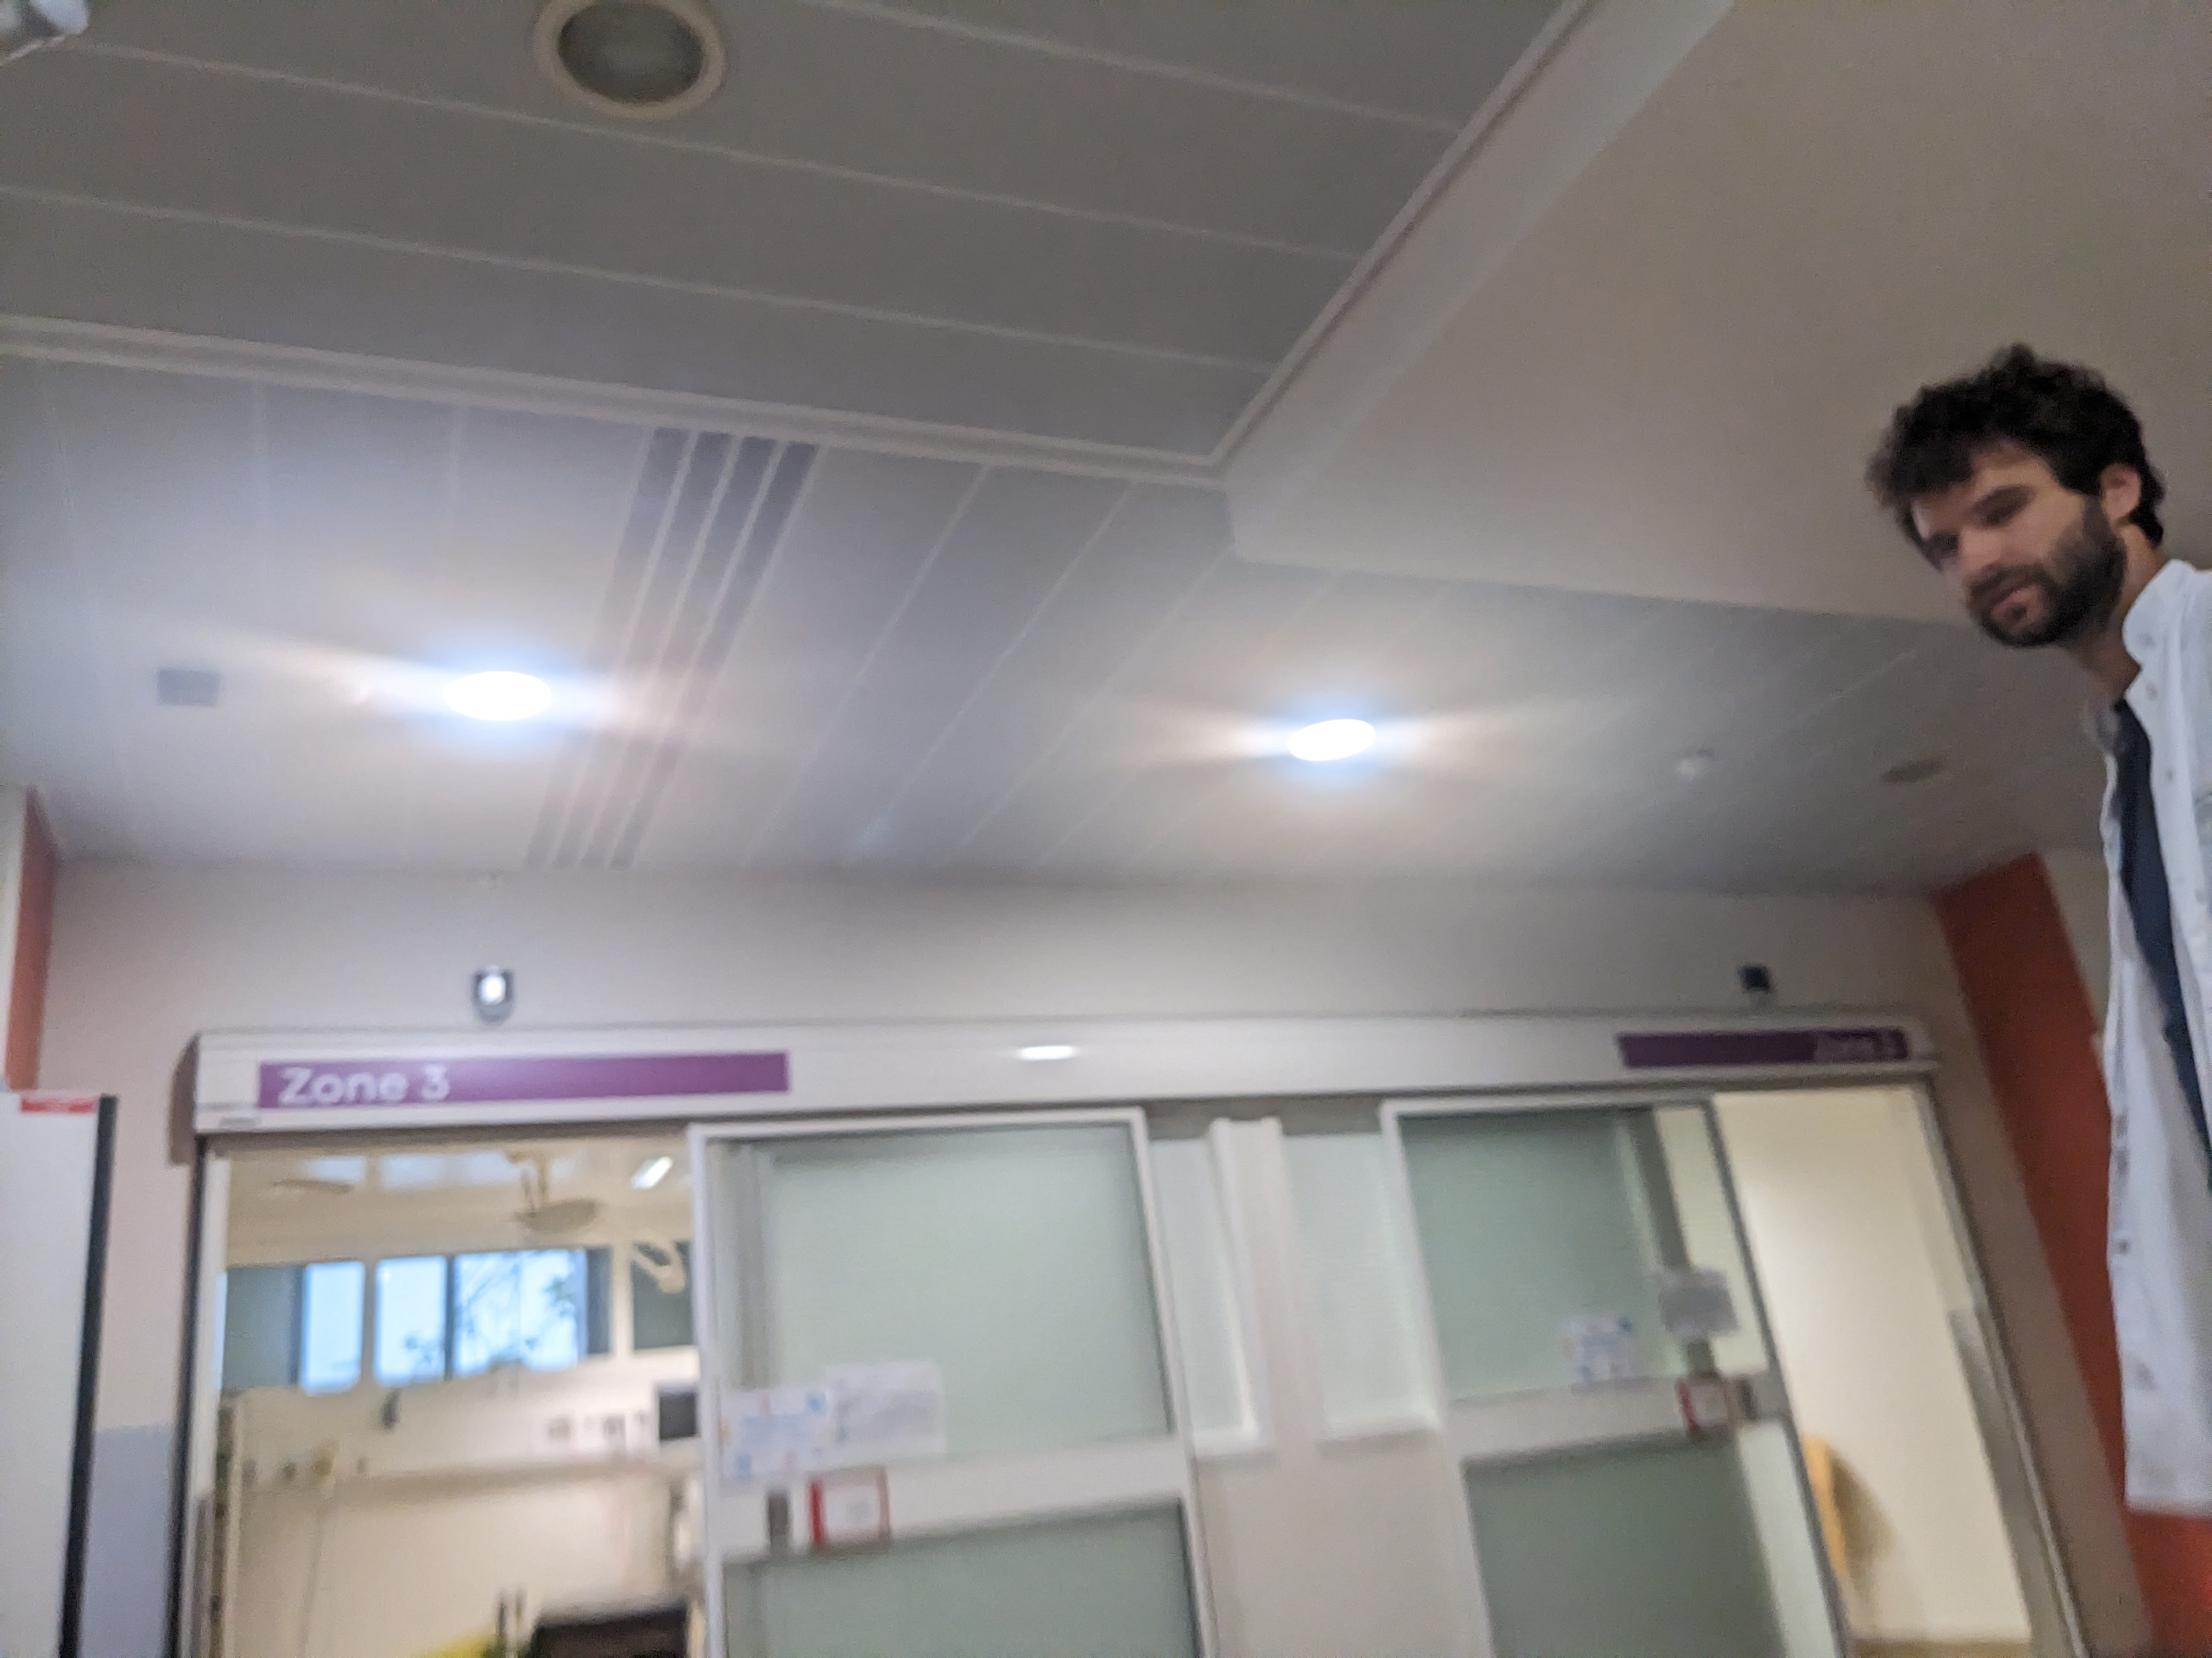
The third event originated in Monaco, France (August 16/17th). I went to the hospital there after I drove to Nice. The Monaco hospital realized that I was in a medical emergency and the ambulance drivers took me to see specifically the neurologists in the Pasteur hospital in Nice, France. I believe even against the ambulance drivers the Pasteur hospital doctor replicated the clinical assault of the first two hospital settings within a single two week period.
Their objective is the same as the murder attempt of me on November of 2021 pictured below:

Their reason for clinical assault is to get away with medical neglect of multiple sclerosis over the past 15 years and now their recent murder attempt attempts. Their reason for the past murder attempt was to get away with the same thing.

Dad knows about the murder attempt above since he flew Mexico City and saw me in the hospital through the end of it. He saw the resulting effect of kidney and liver failure caused by their murder attempt. It was a drug given to cause a cardiac arrest (heart attack). High CPK of 8500 due to their murder attempt means death in most people.
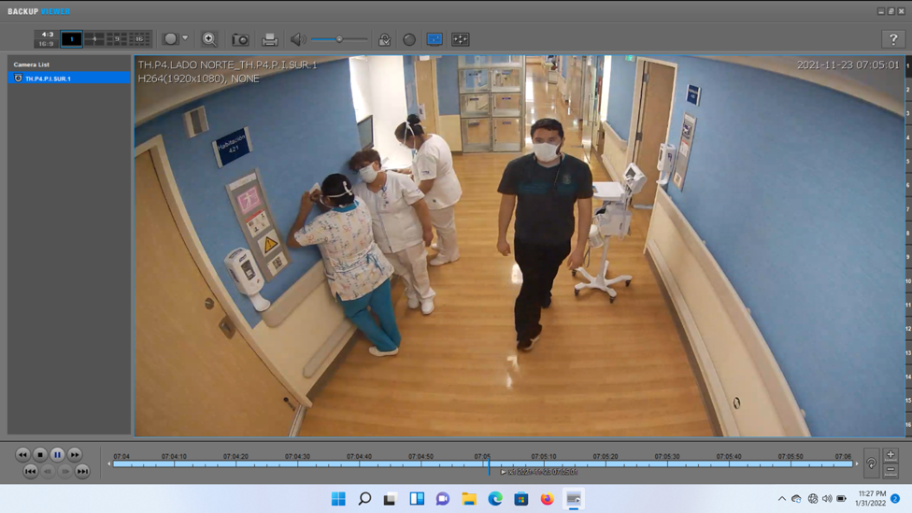
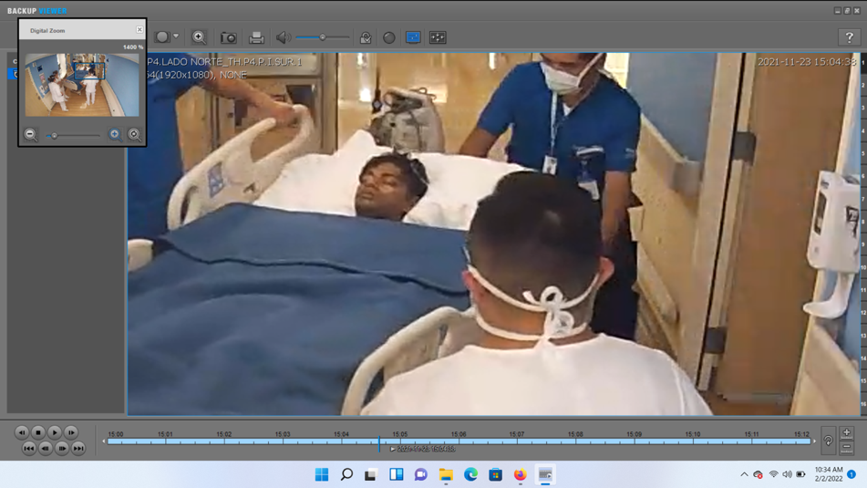
Outside of hospitals on April 2nd 2023 something happened in Tokyo, Japan when I became sick and unconscious (I didn’t do anything wrong) due to tox net and neuro junction (neuro awake) harm (described later). Instead of taking me to a hospital I was taken to a police station by police. I was assaulted (physically harmed) in the police station that night. Its because they were afraid of me being a UN refugee and them getting caught for the medical neglect. Its called refugee persecution. The other doctor (from Yokohama City University Hospital) came to the police station to try to stop it and he couldn’t, he himself is restricted in giving medical help.

So that describes my current situation.

They tried to politicize something simple in medicine with sad reasoning. So in the past I logically sought safety from the harm by being a UN refugee, shown below:
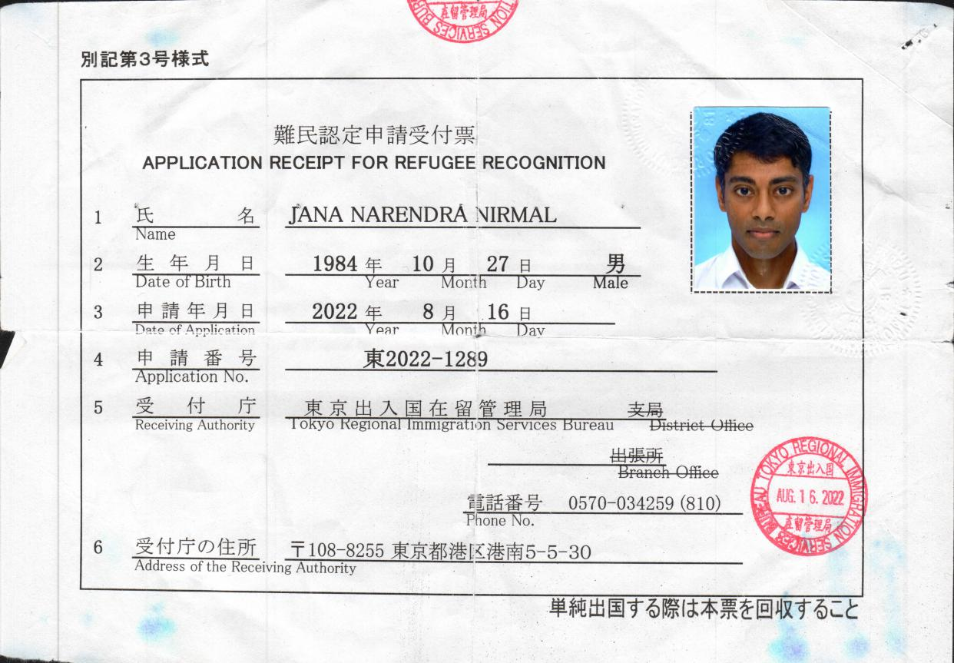
Those are the recent events, I am a UN refugee twice over:

Refugee or not they escalated the harm from clinical harm by a unheard of system to cause harm called tox net neuro junction. Its a esoteric obscure type of system harm.
Im the victim of medical neglect of multiple sclerosis for 15 years which escalated to harm by tox net neuro junction harm by the same people to avoid being caught for medical neglect.
Tox net harm has been going on for about 2 and 3 months now with no way for me to stop it. Its September 10th of 2023 now.

Here is what I know about the system:

It’s a simulation which causes extreme real physical pain by replaying physical pain in time junction from a malady (any malady) in regurgitation. I don’t have access to turn it off. The medical neglect people used it to harm people (me and others) to get away with medical neglect. Thre is a particular type of shielding that protects from it.

The neglect was 15 years so their psychology became agitated well after I applied for refugee status (no relating to refugee status) at the fear of being caught (its not the UN refugee status that caused it). They medically mistreated multiple sclerosis which left me in extreme physical pain (pain around the sides and back of head due to cervical spine lesions) and pseudobulbar effect (PBA) for 15 years but they simply became afraid of being caught and didn’t consider the harm done by it. PBA only happens in brain injuries.
Bio harm evolved to another form of bio harm by bio terrorism/tox net. The 15 years is pictured on the next page (you wouldn’t know, other than that I was sick):
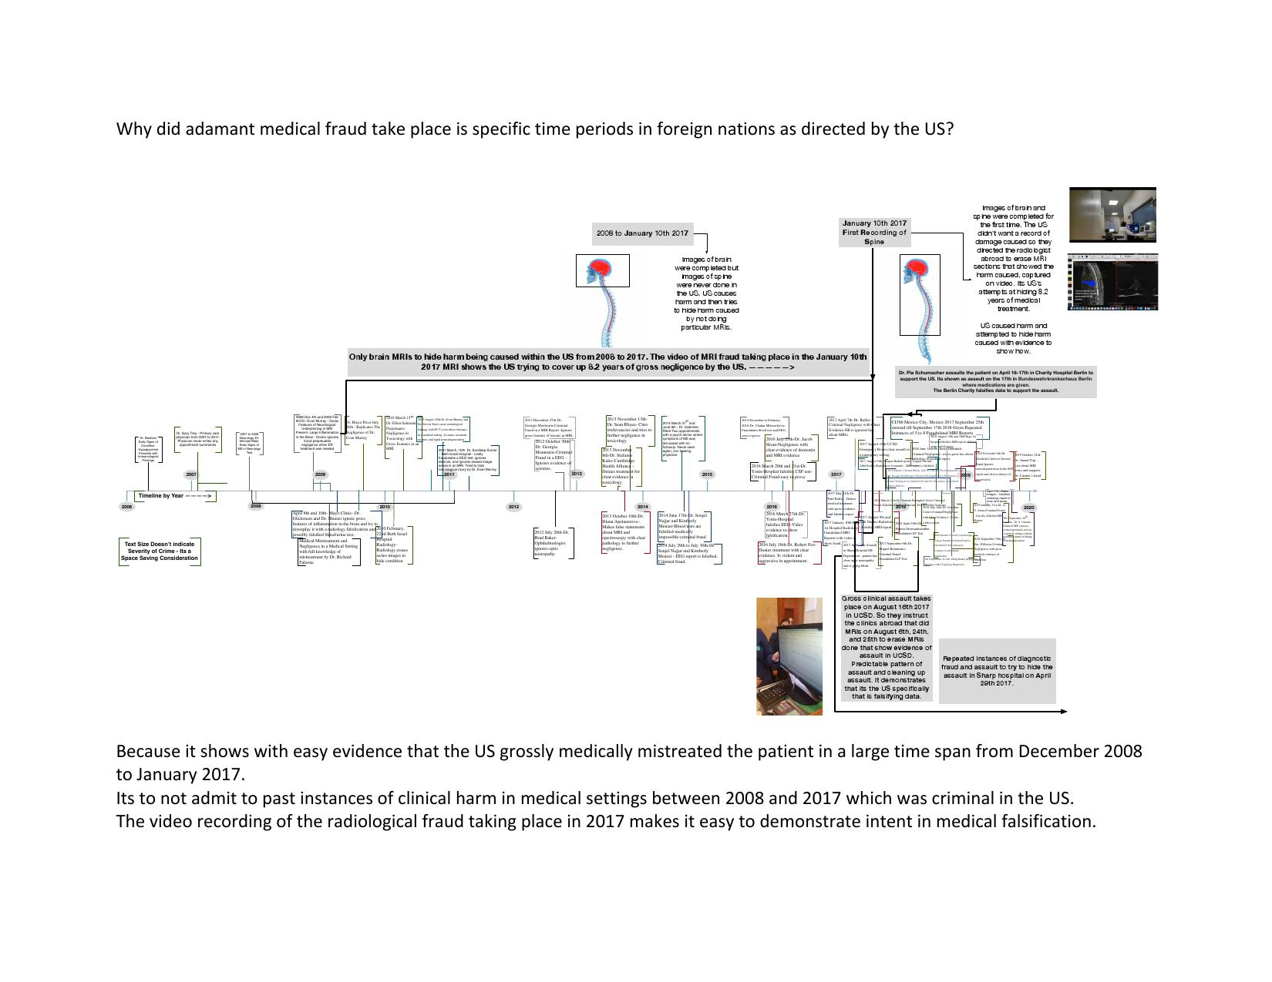
(there is a separate picture)

They kept pushing it to a higher and higher type of harm at a longer length of time and then they finally resorted to the above.

Its due to a dead end in their psychology of both a no reason to cause harm to me and also a poor but extremely harmful idea is perpetuating harm to me in the past.

Dad knew about the murder attempt of me on November of 2021, but it escalated from then to this.

It should be know that the people perpetuating harm are often in paradoxical states which means mental states outside of the surrounding scene; they often can’t maintain a mental state that matches the immediate scene or in the current context. It can be dangerous. There is a tendency towards confabulation (lying) in them. More wrong they do the more confabulation.
Their reasoning is to get away with their past crimes (which was for no reason) now so the reason for my international travel is to build safety from them.

So there is a reason for where I go next. I will probably be gone for a while this time so you have to know past situations.

I have to be there for now. I am a refugee as stated above.

The guys harming me spend most of their days unnecessarily being angry so that would eventually escalate to physical harm and they did. You guys have to know the nature of their harm, they are in paradoxical states.

My risk is physical harm now and in the past was medical clinical harm.

These are warnings:

Tox net neuro junctions cause physical harm and death in many cases. Its a medical diagnostic tool that became a bioterrorism method.
In time verse it is estimated that it caused multitude of deaths.
Tox net causes extreme physical pain, psychology shifts, and headaches that no one can physical withstand.
Neuroshare systems cause pain by sharing pain from tox net junctions and there is nothing I can do to stop it.
Even if you don’t know what that means you need to remember what you need to avoid in the future.

Tox net and neuro verse is part of a digital machine interface system.

I never involve family in this case but there are a bunch of pretend creatures created by AI systems that you have to be aware about (they are called mimic characters). Our family is well educated and well formed but AI creates mis portrayals of family. Their idea is that in order to mistreat me they have to mis portray family so they created portrayals of different characters.

Im not involved in anything either, simply a victim of medical neglect.
Those harming me’s family structure is often unstable so they have a group mentality to polar reaction of instability which now results in physical harm in groups mentalities.
They often in my case commit crimes together as groups; which is clearly not normal.

They often don’t realize that it is 2023 and not 2012; non psychologically evolving groups. Their psychology shift is a avoidance mechanism by a group of people. People can’t think independently to the point of violence a times.

*“Those harming Naren are iffy people, they harm people if you arent nice to them even if they do something wrong.”

There is a problem with US military and US armed forces because they are not psychologically stable. The idea by them (since this is a multinational case) was to support the medical harm of me but for no reason and to not get caught. But the harm and no reason makes them unstable. They have a like and hate mentality (rapidly cycling mentalities). They can only see a us against them with no reason at times.

People need to keep pain medications and sleep medications due to their simulation systems. Pain medication have to be consulted with an anesthesiologist. Pain medication have to shut off all pain perception in the body. Sleep medications like lemborexant, zolpidem might work for sleep. The sleep medications are for neuro awake in neuro junction, they amplify wakeful states to keep people up for days with the intent of death.

People in my past aren’t people that I ever reference or interact with, I simply came across them in the long ago past (more that a decade ago). they are largely people that I randomly came across but they still harm me.

The system also mentions visors and other technology that I have not seen/no idea about.
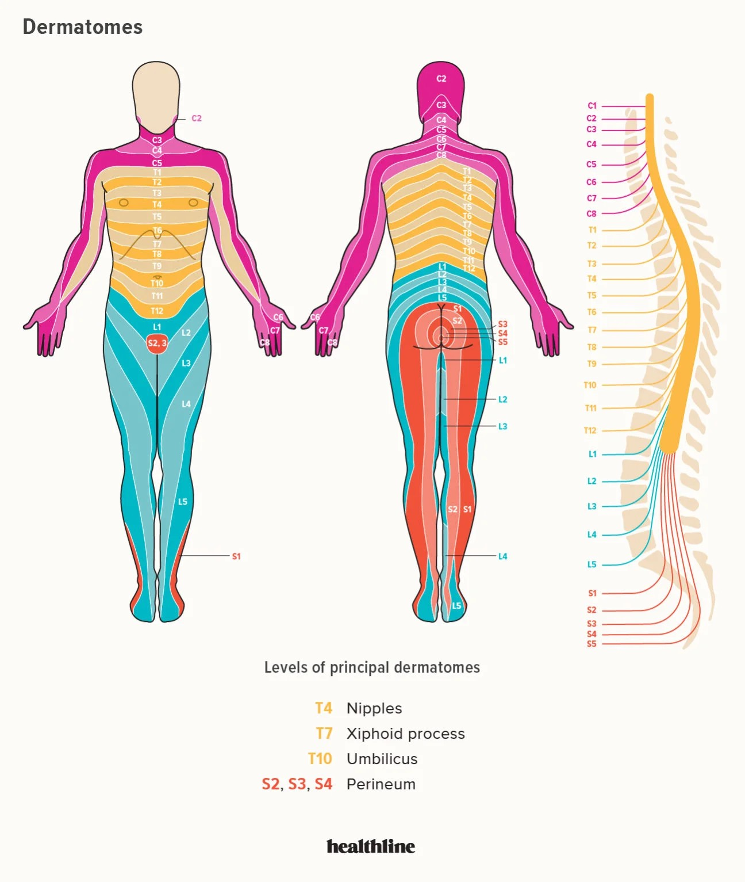

The physical pain from the simulation system originates for cervical spine lesions, so its a headache around the sides and back of the head due to a manganese toxicity (manganism). According to this map shown below (the pink area is in pain):

Manganism (manganese poisoning) causes Multiple scleroirs (MS/ALS).

I was excessively harmed by Japanese immigration over the last year by repetitive scenes by them and situations where I had to go to the Japanese immigration office repeatedly (10s of times a week); which is tiring for everyone to see to the point of psychological abuse. Refugee harm is due to US instigating Japanese immigration is prevalent in my case.
The US harms me because of me being a refugee.

Japanese immigration goes through a phase of self harm and self effacing behavior due to the US. They have no reason self harm behavior because of the US (because they want to grant refugee but they are limited by the US).
US was massively unhealthy for Japan to interact with (the year before during and after I was there).
There are people in the US and Japanese population who become self effacing; they cause self harm. There might be a high rate of suicidality in Japanese population simply at the idea of interaction with the US population. They know im not the cause but they have no idea what to do about the US.

Before the last 2 years and 3 months this is what happened:

I was a refugee in the United Kingdom:

In the past they perpetuated theft of my medications to try and keep me sick, here are videos of it:
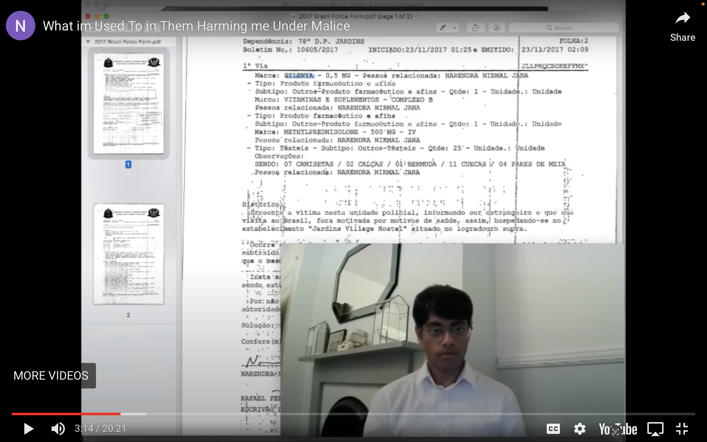
(a video of a police report filed in Sao Paolo, Brazil for theft of my medications)

It included falsification of medical data caught on video:
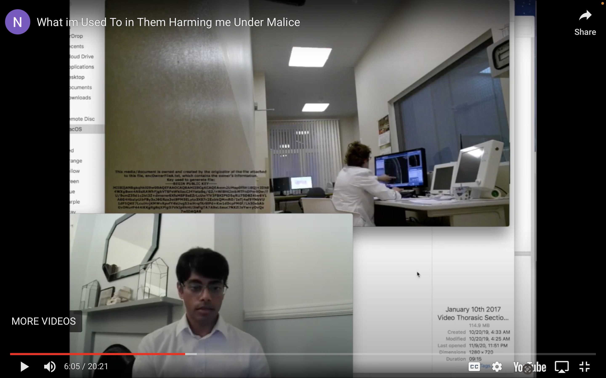

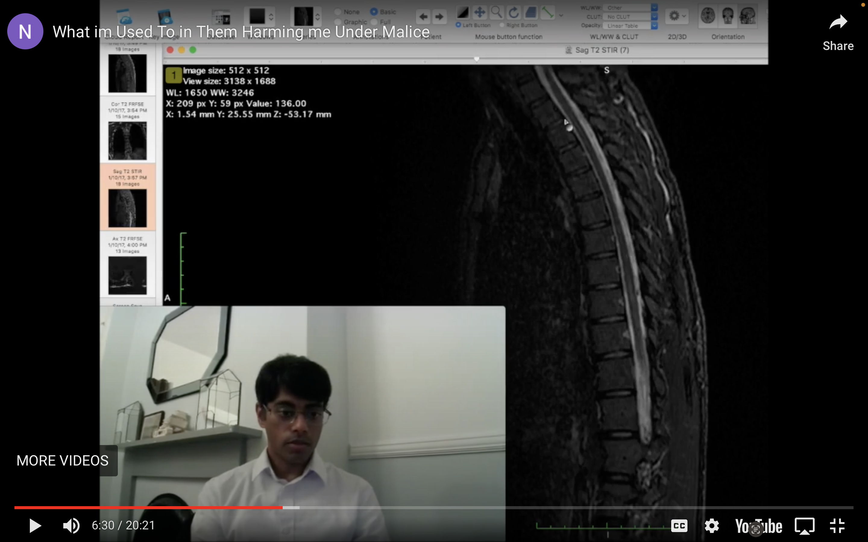

Radiologist falsified medical data to perpetuate medical neglect. This caused clinical harm/clinical assault in the past.

The time length of harm is in this graph here, this is what the US didn’t want to get caught for:

Their current behavior was preempted by their past behaviors. If they resorted to theft in 2017 they would resort to aggression and they did so so I needed to seek personal safety from their harm then and that is the reason I go abroad to seek personal safety from their medical harm (asylum is later when they wouldn’t stop).

So with the repeated instances of both medical and physical harm by a bunch of random people in a unfounded harm of me I have to report their crimes to a particular board so that I can get medical help for neurotoxicology caused MS. To me its simply medical help and then normalcy.
There is another part which is social harm. It produces a problem that’s hard to comprehend; there is forced social isolation of me but there is a aggression by people by simply not allowing normalcy in social settings.

They for some reason think this is a social cause but its medical. They state other absurdities as well which are immature and nonsensical that I don’t want to deal with. No one wants to deal with all the people causing this type of harm.

So I have to inform you because recently there have been more instances of physical harm and I could easily be hurt in any setting here or aboard.

The cause is the two original doctors form 2007 and 2008 and some peripheral characters not related to me or medicine perpetuated. The 2008 December doctor is a direct cause of harm.
The peripheral characters who caused harm are Arnab Raychaudhury (primarily in social ways) and people I haven’t seen for one to 2 decades (no communication by me in anyway).
US Army referenced some old forgotten characters but they are all disjunct characters outside of modern context (I don’t know they for more that 15 years); some bad characters.

