Narendra Jana
Email: realn@mykolab.com
Cell: +17812235780

I believe my doctor’s death is related to those who are effecting me negatively. The reason why I state that is because he had given the more complex therapy for my condition in the hospital, pictured below:
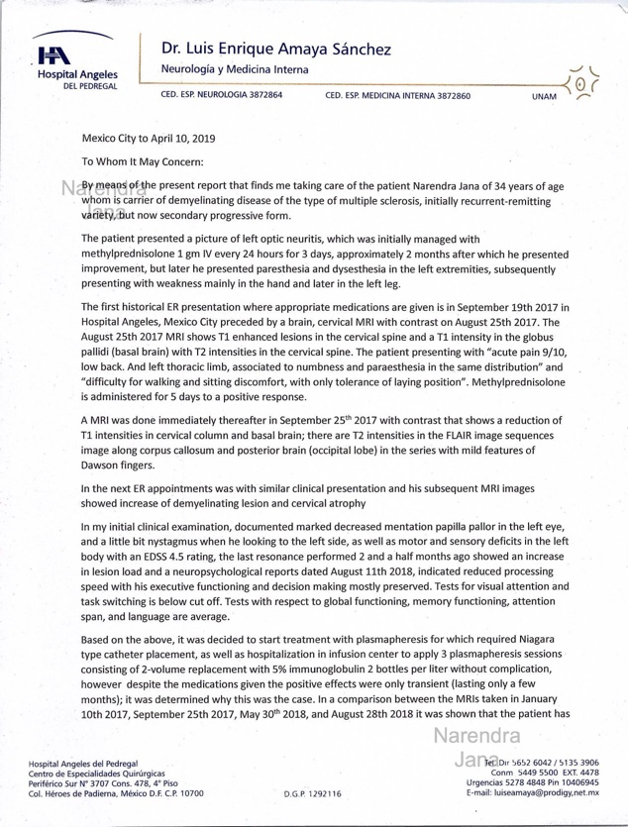 | 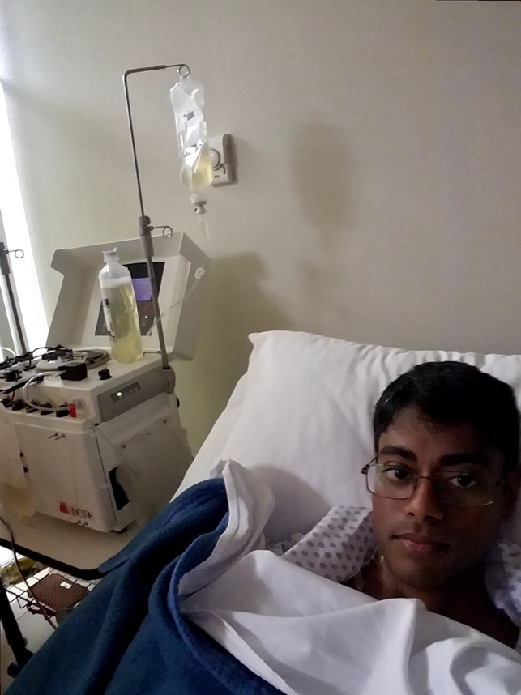
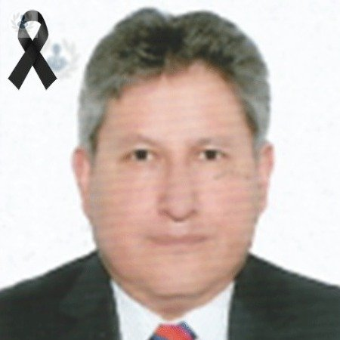

When I went to the hospital in 2021 his wife told me that he had died of COVID. So I couldn’t get the treatment in Dr. Amaya’s clinic. But I don’t believe he had died of COVID because their attempted murder of me happens shortly thereafter in the next hospital in Medical Sur in Mexico City, which is pictured below:

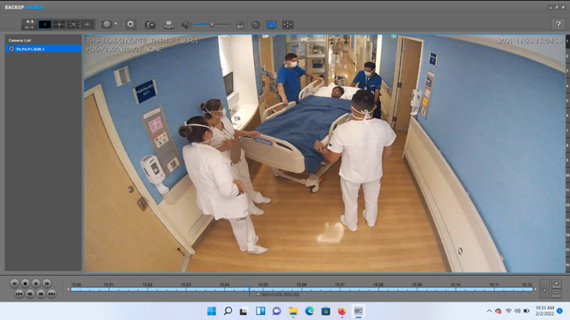 | 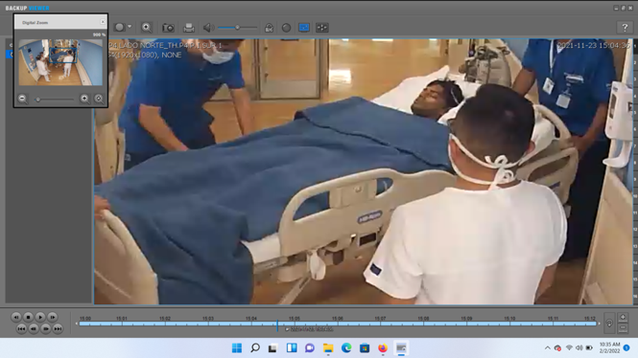

The first hospital by death of my doctor forced me to go the next hospital for inpatient treatment and the inpatient was a murder attempt by those harming me in the US. The next hospital is set up to a murder attempt. So Dr. Amaya’s death is closely tied to my case. The doctors in Dr. Amaya’s clinic denied treatment and then the next hospital appointment in Medica Sur happened.

